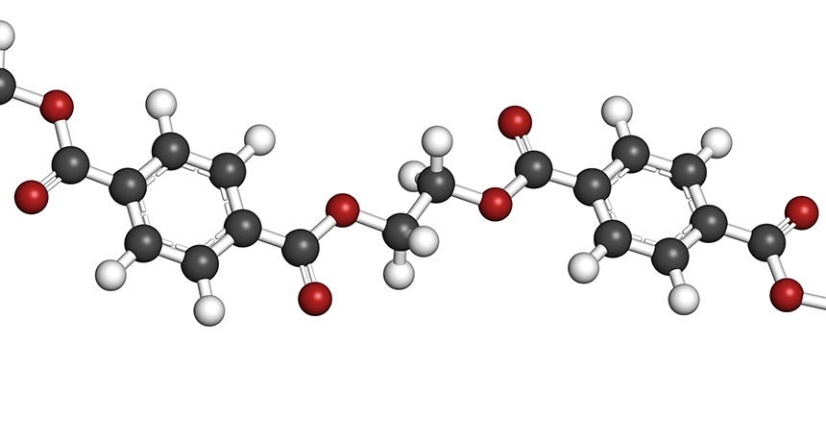

***Chemistry Project Work***

*Name:-* ***Arnab Chatterjee***

*Class :-* ***XI-Sc***

*Sub:-* ***Chemistry***

*Topic:-* ***Hybridisation***

